Exercise 2

# Monty Hall Problem (Should i switch or should i not?)

### Using Genie

The first step is to model the Bayesian network. The door opened by official is directly dependent on MyChoice and ContainsPrize because the official is not allowed to open the prize door nor the door that we chose at the start. ContainsPrize and MyChoice each have a uniform 33% probability distribution for each door. Because of the added rules, the door opened by official does not have the uniform 33% probability distribution, and is being affected by both its parents (ContainsPrize and MyChoice). Therefore we fill in the definition table of OpenedByOfficial in Genie.

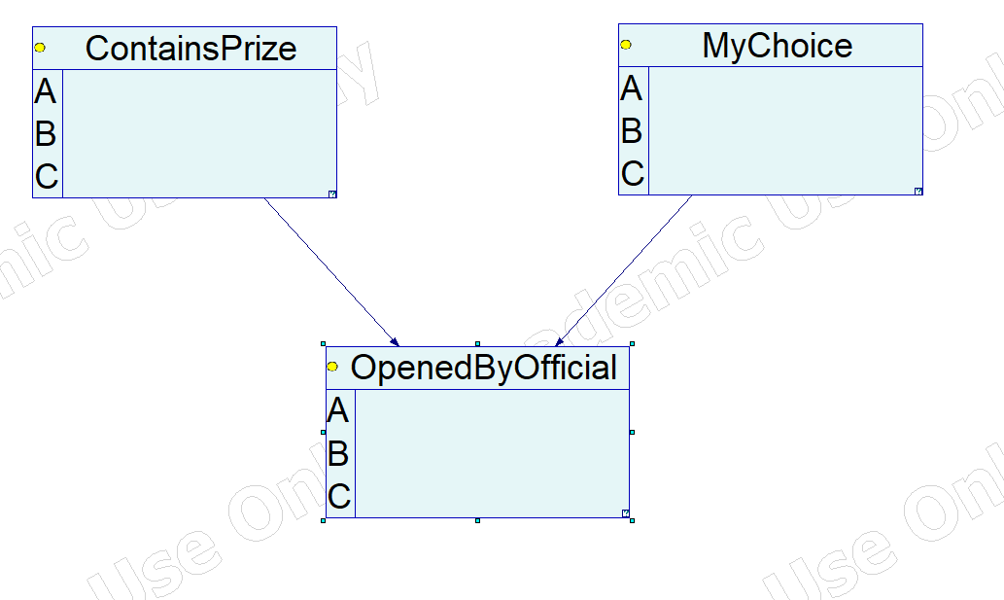

Figure : Bayesian network model dependencies.

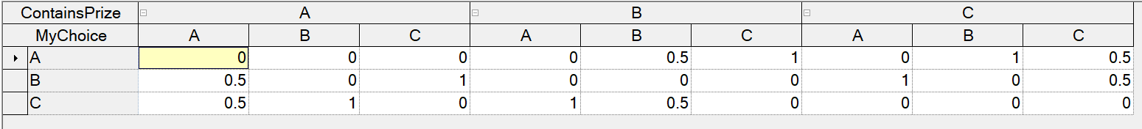

Figure : Conditional probability table of OpenedByOfficial.

## Why you should switch!

Assume we picked door A and the official opened door B.

Let us calculate the following probabilities:

Figure : Notice how switching to door B would have resulted in a 67% chance of getting the prize money instead of sticking with the same door and having a 33% chance? The initial door choice and the official door choice would result in the same probabilities for different initial conditions as long as the rules are followed, in other words, switching would always result in a 67% chance of getting the prize.